

**Minor Dissertation Report**

**on**

**HICA MEDICALS**

### A Project Report Submitted In Partial fulfillment of the Requirements

**For the degree of**

Bachelor of Technology

# By: Team HICA

**AYUB ANSARI (Roll No-1904310100024)**

**CHANDRABHAN GUPTA (Roll No:1904310100028)**

**HUSAIN AHMAD (Roll No:1904310100031)**

**IJHAR ALI (Roll No:1904310100034)**

Under the Supervision of

# Mr. Mithilesh Singh Yadav

### (Assistant Professor)



**Department of Computer Science & Engineering**







**Lucknow, UP**

**CANDIDATE’S DECLARATION**



I hereby declare that the work presented in this report entitled “**HICA MEDICALS**”, was carried out by me. I have not submitted the matter embodied in this report for the award of any other degree or diploma of any other University or Institute.

I have given due credit to the original authors/sources for all the words, ideas, diagrams, graphics, computer programs, experiments, results, that are not my original contribution.

I have used quotation marks to identify verbatim sentences and given credit to the original authors/sources. I affirm that no portion of my work is plagiarized, and the experiments and results reported in the report are not manipulated. In the event of a complaint of plagiarism and the manipulation of the experiments and results, I shall be fully responsible and answerable.

## 

## Name:Team HICA

## AYUB ANSARI (1904310100024)

**CHANDRABHAN GUPTA ( 1904310100028)**

**IJAHAR ALI ( 1904310100034)**

**HUSAIN AHMAD ( 1904310100031)**



**CERTIFICATE**

This is to certify that Your **Team HICA** has carried out the project

work presented in this report entitled “**HICA MEDICAL**” for the award of

Bachelor of Technology from B.N. College of Engineering & Technology,

Lucknow under my/our supervision. The project embodies result of original

work, and studies are carried out by the student himself and the contents

of the project do not form the basis for the award of any other degree to the

candidate or to anybody else from this or any other University/ Institution.

### Signature

**(Mr. Mithilesh Singh Yadav) Assistant Professor**

**ACKNOWLEDGEMENT**



An assignment puts to litmus test of an individual’s knowledge, experience and thus sole effect of an individual are not sufficient to accomplish the successful completion of project involving interests and effort of many people. So this becomes my obligator thanks to all of them. I would also like to thanks to **Dr.(Prof) Ashutosh Dwivedi (Director, B.N. College of Engineering & Technology)**, **Mr. Vinay Kumar (Head of Department) & Mr. Anil Kumar Singh (Asst. Professor)** for their constant support and guidance all through the making the project. I acknowledge unforgettable guidance, invaluable suggestion and constant moral support to my classmates during this period. I am also grateful to technical staff for providing me the right kind of environment and resources whenever needed.

My sincere thanks to all staff members for their contribution in coordinating and Co- operating with me for successful completion of my project.

TABLE OF CONTENTS

1. **Abstract**
2. **Introduction.**
3. **Project Specification.**
4. **ADLC.**
5. **Data Flow Diagram.**
6. **Coding.**
7. **Future Enhancements.**
8. **Result.**
9. **Refrences.**

**Abstract**

This project deals with E-health web application framework, and responsive web design which aims to adjust the presentation mobile devices and also other devices. This work presents the whole development process of the web-app framework which provides instructive supports for Online Consultant Medical shop overview other E-health field application. The report consists of the following main parts: analysis, design and implementation (coding). A prototype is developed by using HTML, CSS, Java script and PHP technologies.

This Website Provide the overview of the hospital information like Doctors, Medicine, Appointment and address. This website helps to various Organization to Online Marketing and Co-Ordinates of the peoples.

**INTRODUCTION**

The rapid development of smart phones and mobiles devices, It becomes very popular.That people more prefer With to access the information through this flexible way. So the requirement of proper interface according to different devices become a hot topic and the goal will motivate the use of RWD(Responsive Web Design). It aims at crafting sites to provide an optimal viewing experience in easy reading and navigation with a minimum of resizing, panning, and scrolling across a wide range of devices such as from desktop computer monitors to mobile phones.

This Website **HICA MEDICALS**  that mainly provide the all the infor-

mation about of the Hospital and also the doctors in particular

disease expert. Its also provide a best facility every patient.The modern

day healthcare needs and delivery is complex, and the use of

ICT has made some positive impact in attending to such needs that

e-health applications require. The project is about E-health

web application framework and responsive web design with based

on a concept overview of a responsive website.

**PROJECT SPECIFICATIONS**

* + - Project Title : HICA MEDICALS
    - Front End Tools : HTML,CSS
    - Back End Tools : PHP,JAVA SCRIPT
    - Operating System :Microsoft Window 7 to 11.
    - Web Server : PHP
    - Web Browser : Chrome
    - Editor : VS CODE
    - Hardware : 64-bit 1.70 Ghz , 4GB RAM

**ADLC DIAGRAM**

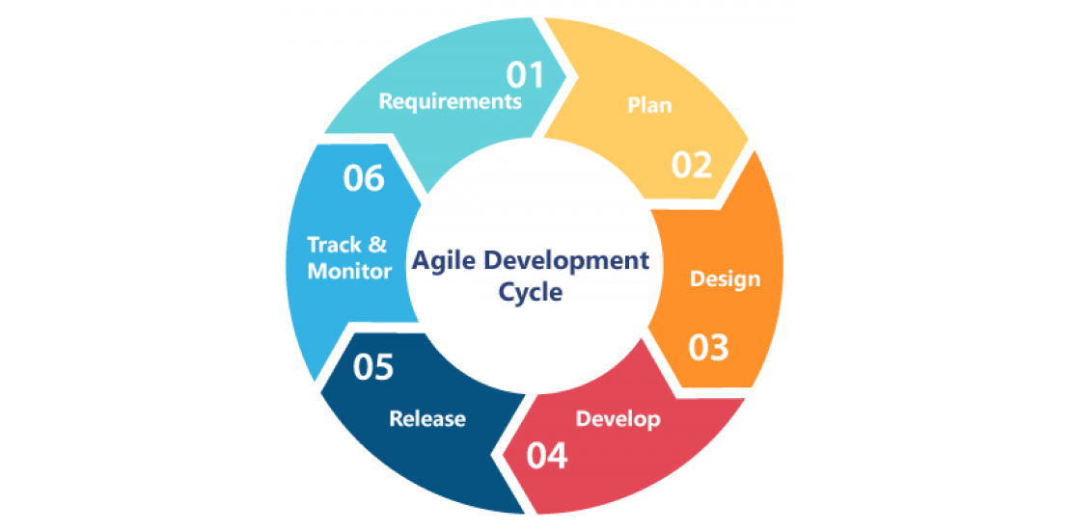

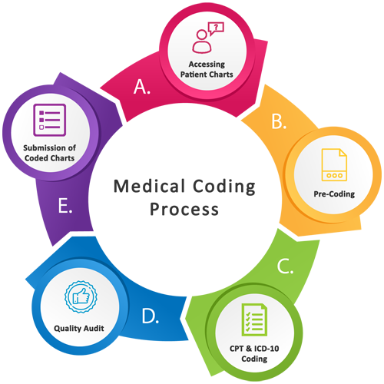

**DATAFLOW DIAGRAM**

**HOME PAGE**

**HEADER**

**SUB PAGE**

**SIDE BAR**

**FOOTER**

**WEBSITE**

**SUB PAGES HEADER FOOTER**

HOME BOOK APPOINTMENT ADDRESS

ABOUT US EMAIL CONTACT

SERVICES SOCIAL ICONS AND LINKS COPYRIGHT

APPOINTMENT NAVIGATION BUTTON

GALLERY

DOCTORS

CONTACT

**NAVGATION/SIDE BAR SERVICES**

HOME BUTTON SURGICAL MATERIAL**

ABOUTS US BUTTON FITNESS MATERIAL**

SERVICES BUTTON WHEEL CHAIR

APPOINTMENT HOSPITAL ACCESSORIES

FIRST AID

AMBULANCE

DOCTOR APP**

**Future Enhancement**

Since the framework and a prototype have been done in the project with in limited time, there are some ways that we thought can be further improved and implemented

In the future work.

Here some services can be implemented in future:-

* **DOCTOR APP**
* **ONLINE MEDICINE ORDER/E-SHOP**
* **FITNESS MATERIAL**
* **ONLINE HEALTH CHECKUP APPOINMENT**

**DOCTOR APP:**

In The future it might be possible to upgrade to a doctor app to checkup and

interaction in between patient and doctor.

This website might be Connect with a Cloud Server and a live Android app.

It will able to handle a big data and sharing the beneficial information.

**ONLINE STORE:**

In the future this website the upgraded in form of E-shop for Selling and deliver the

Medicine of the patient.

The patient will able to make a order of the his particular medicine and many more.

It offers a basic common model which can be used by some special E-health application development in the future.

**FITNESS MATREIAL:**

It provides a worth guideline on Fitness/E- Health we application for people self- care management. And the model is designed to be applied to develop a specific application aiming to the diabetes self-care management.

**RESULT/SCREEN LAYOUTS**

**HOME:**

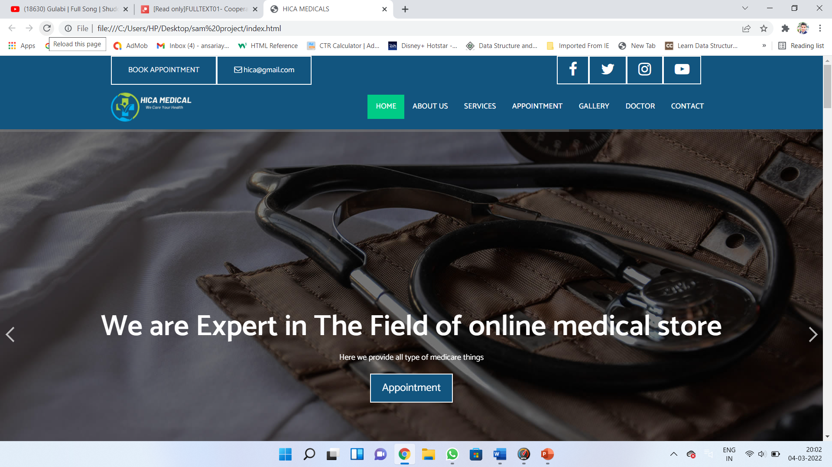

**ABOUT US:**

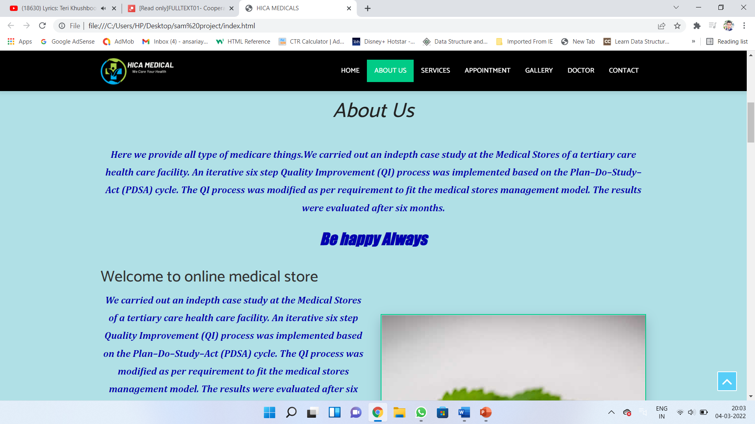

**SERVICES:**

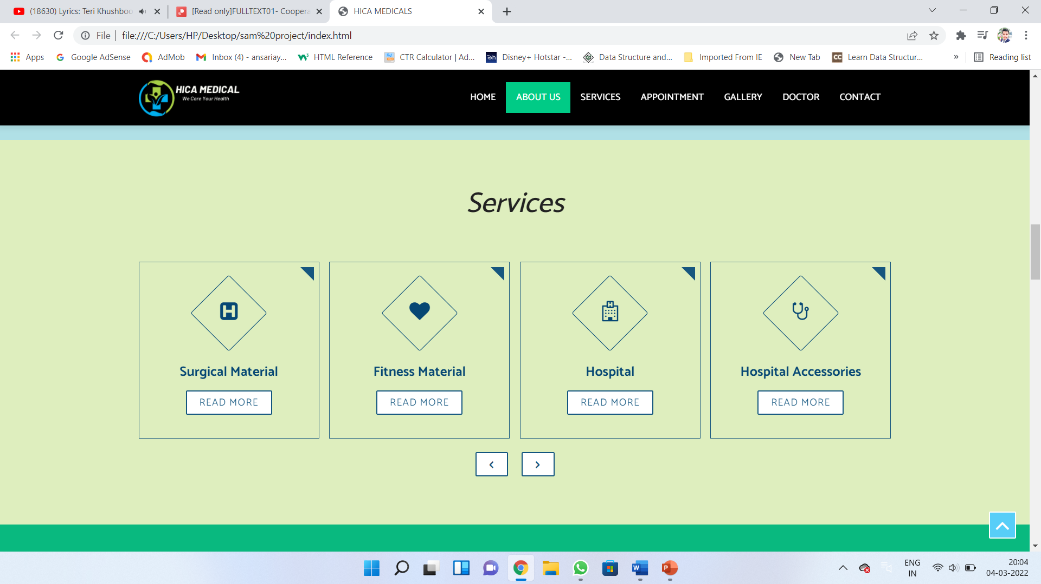

**APPOINMENT:**

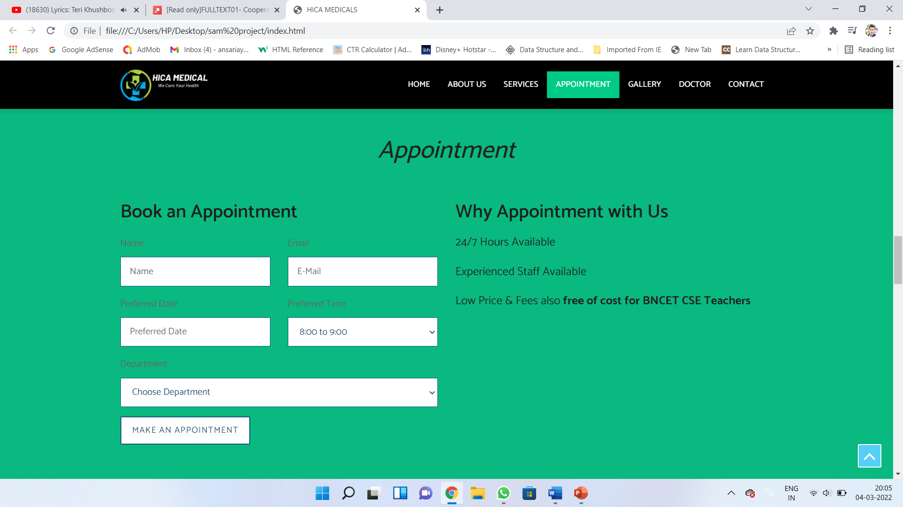

**GALLERY:**

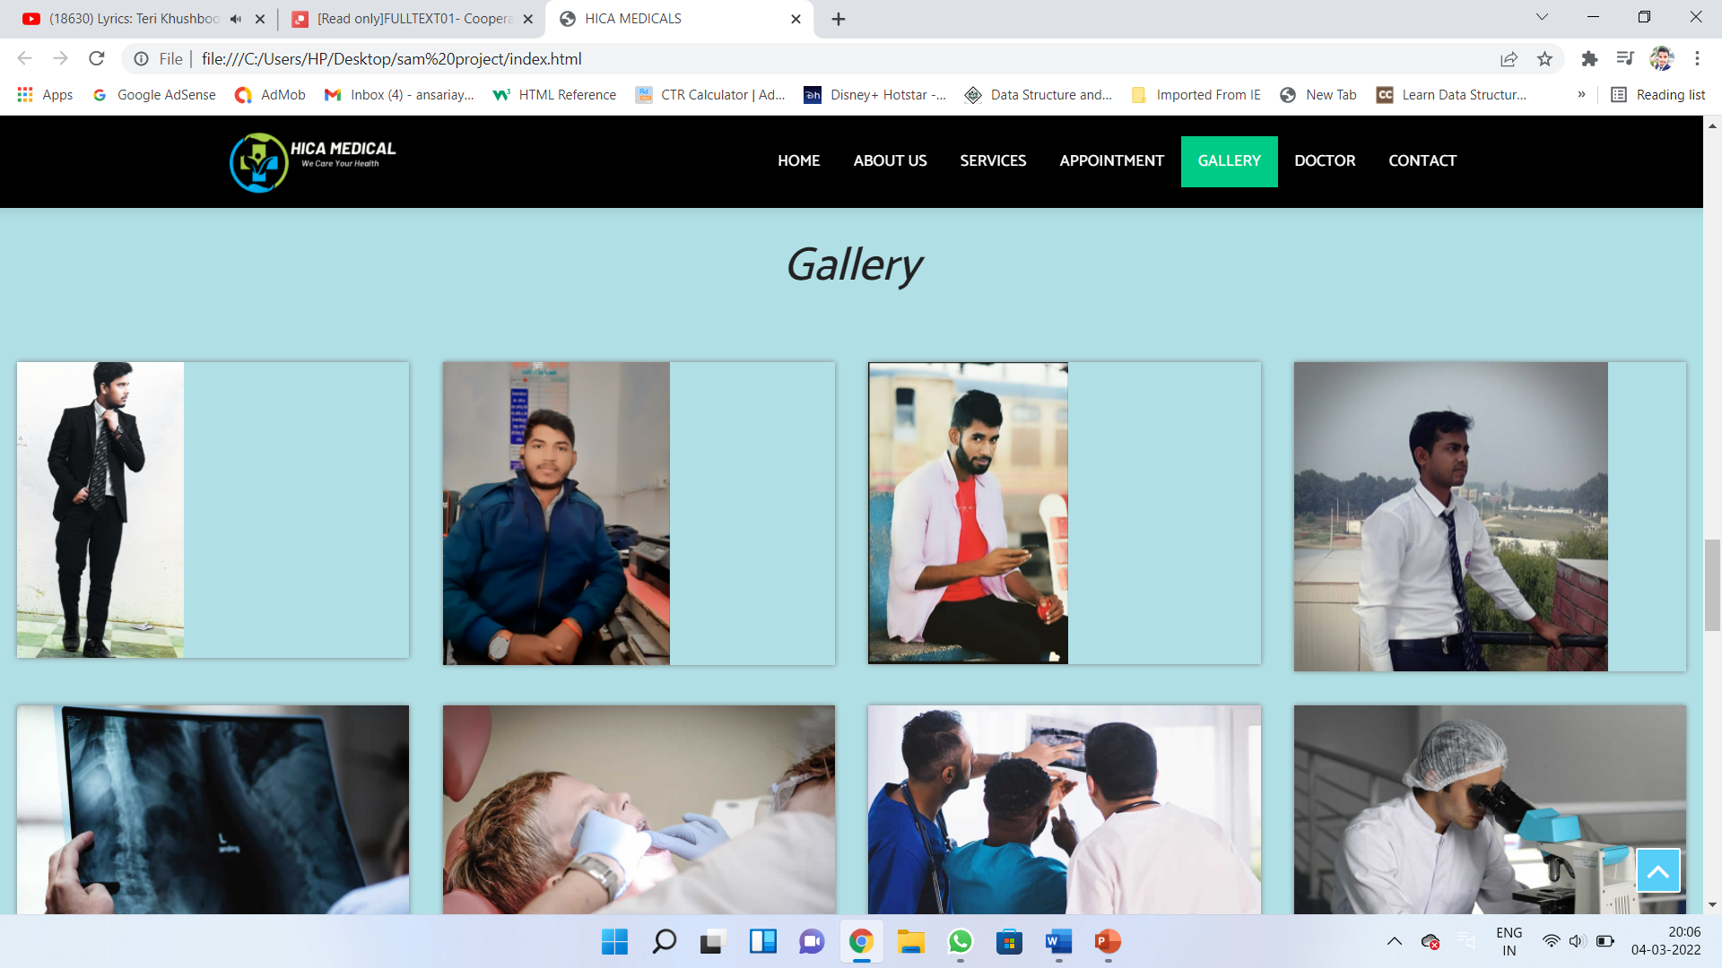

**DOCTORS:**



**CONTACT US:**

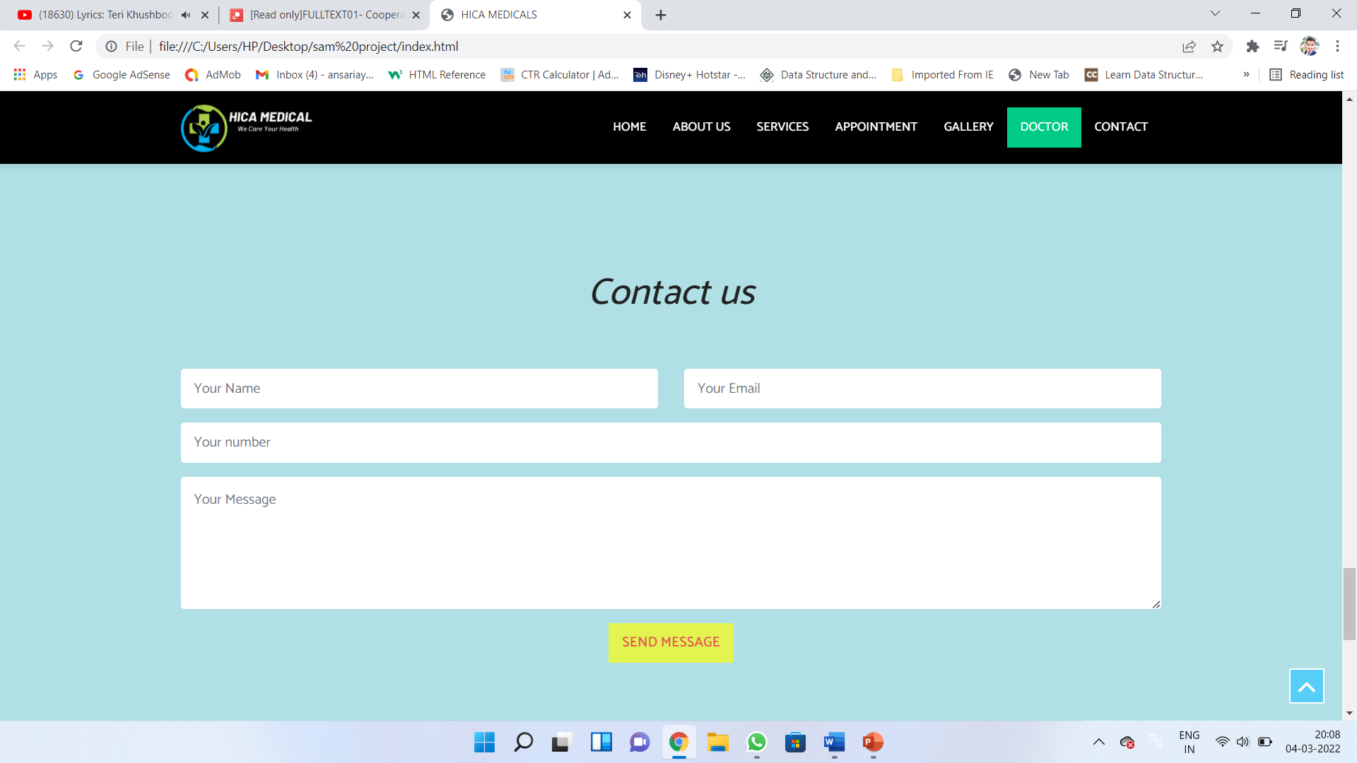

**ADDRESS:**

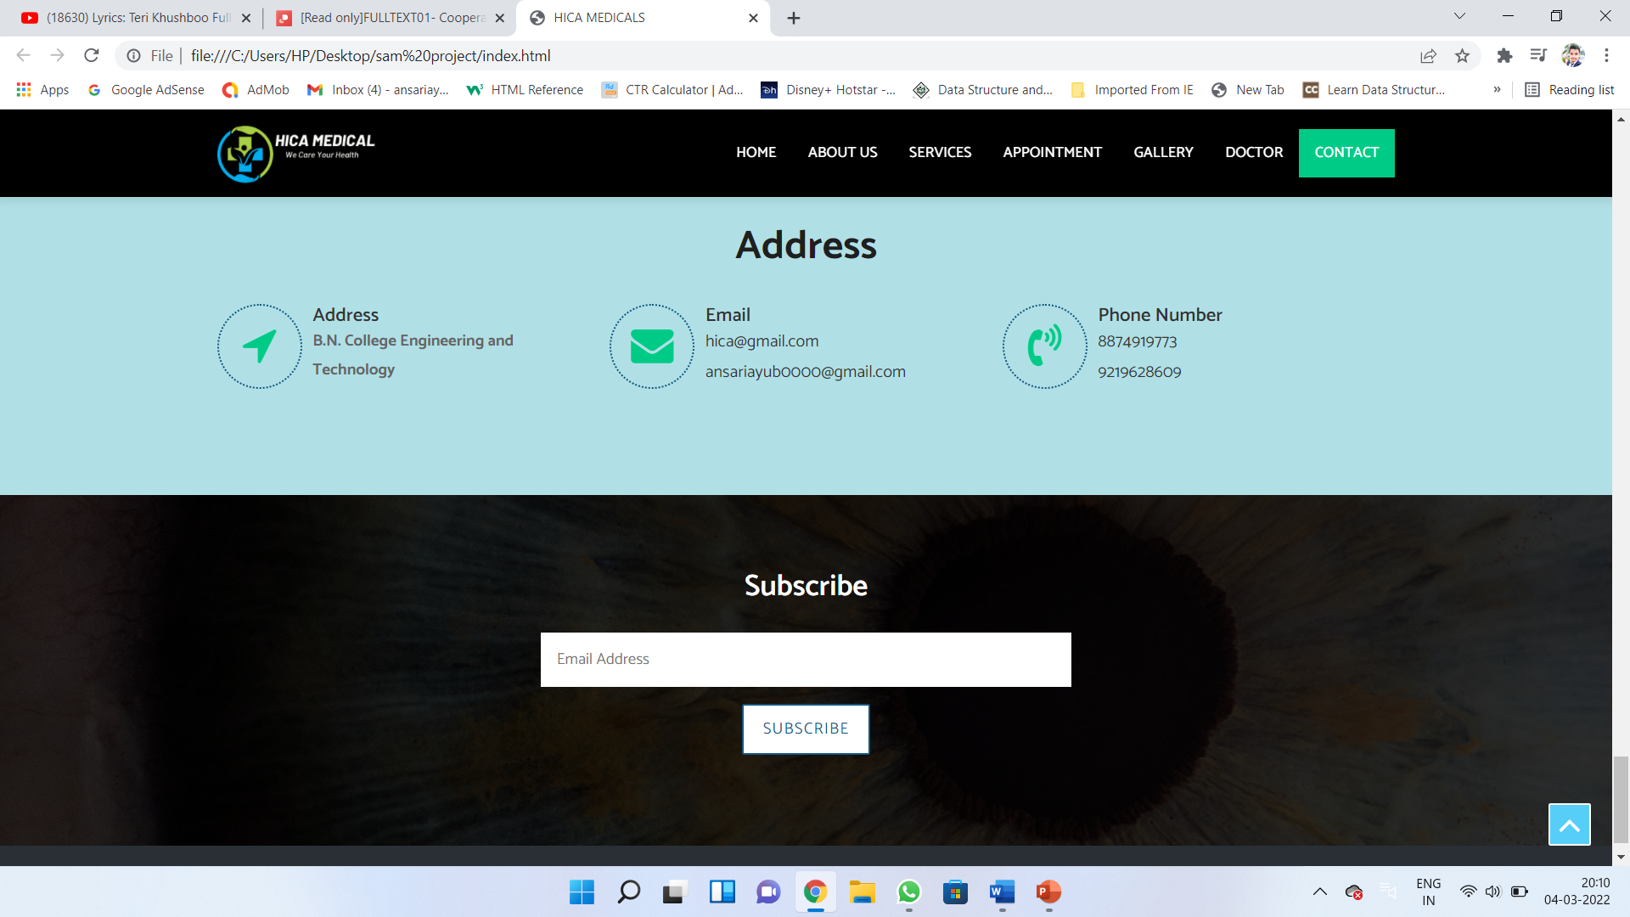

**REFRENCES:**

[**www.w3school.com**](http://www.w3school.com)

[**www.geeksofgeeks.com**](http://www.geeksofgeeks.com)

[**www.tutorialpoints.com**](http://www.tutorialpoints.com)

[**www.javapoint.com**](http://www.javapoint.com)